**Assignment 06**

**1.Fixed Front Method :**

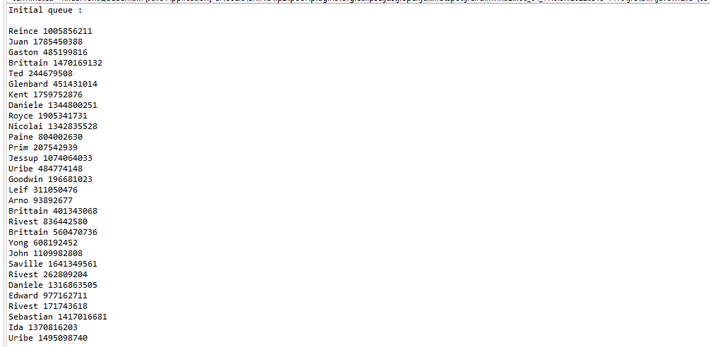

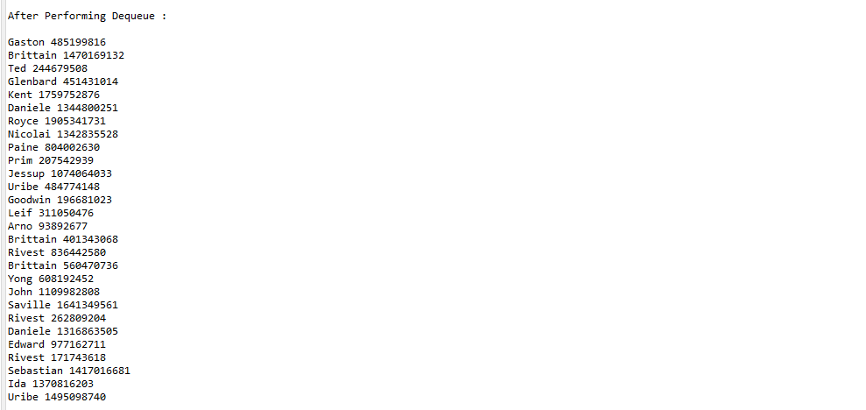

**2.Floating Front Method :**



